Lasham Booking System User Manual

41D Software

Contents

Getting Started 2

Logging In 2

Landing Page 4

Menu Buttons 5

Bookings 6

Making Bookings 7

Cancelling Bookings 7

My Bookings 8

Booking Slot Management 9

Admin View 9

Editing Slots 9

Slot Duplication 10

Slot Visibility 10

Deleting Slots 10

Creating New Slots 10

Print View 11

Admin Page 12

View Users 12

Add Users 12

Remove Users 12

Edit Members Info 12

Appendix……………………………………………………………………………………………………………………………………………………………………13-20

# 

# Getting Started

## Logging In

When you first access the new booking system, you will have to accept cookies. Then you will be taken to a login page, as below.

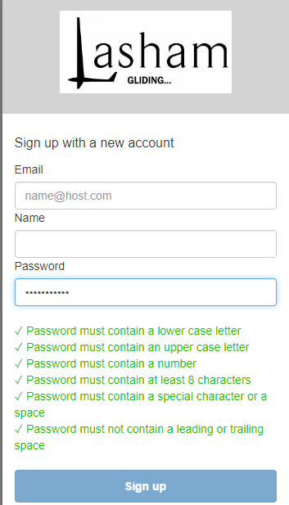

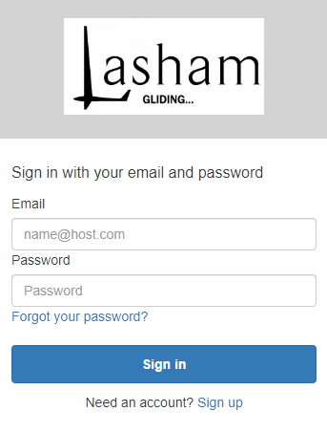

If this is your first time accessing the booking system then please click “Sign Up”  
You will be prompted for your name and email. Please take care in spelling your email and giving the First and Last Name that you wish to appear on the system.

The password policy is as follows:

* Password must contain a lower case letter
* Password must contain an upper case letter
* Password must contain a special character
* Password must contain a number
* Password must contain at least 8 characters

You will be asked for an email verification code and an email will appear quickly for you to do this.

Once you have entered verification, LGS will verify the account within 24 hours. This two stage verification process enables tight security of the booking system.

FYI once signed in (both for the first time and in future sign ins) you will be signed out after 60 mins automatically for security.

## Landing Page

Upon signing in you will be taken to the landing page below. (screenshot from desktop site, it will be similar on mobile)

You will be presented with a short help display, this can be opened at any time by using the help button in the main menu bar.

The landing page contains members information, replacing the members information section on the old site. The above screenshot is representative, the information may be changed at any time by Lasham staff.

## Menu Buttons



The landing page has 4 menu buttons, although they are fairly self-explanatory they are:

* View Bookings – access the booking system
* Briefing – zoom link for the daily briefing
* Help – view help display
* Sign out – sign out of site

# Bookings

Using the View Bookings button will take you to the booking system, as shown below (will look slightly different on mobile on account of the different screen size).

In the header, there is a link to the booking rules. If the signed in name does not match up with who you are, please contact the office!

The two menu buttons take you back to the landing page “Members Info”, and to the My Bookings page (see later chapter). Below these, there is the date selector, which selects the date for viewing bookings (e.g. in the example the date is 08/05/2022, meaning that we are viewing the bookings for 08/05/2022 (April 8th). You can quickly change days using the previous and next day buttons, or from a calendar by clicking on the date (device permitting).

The bookings are done in two main tables, one for instructor slots and one for solo slots. The instructor slots are created by the office. The solo slots are available for 2 weeks ahead of the present day.

## Making Bookings

To book a slot, simply select the book button next for each slot. You will be presented with the following window.

You can optionally enter comments about the booking (for solo slots), or the training that is required (red card, pre/post solo etc). You can also check the booking rules through the link provided. If you change your mind at this point, you can cancel and not book the slot. To confirm the booking simply press the confirm button. If everything is fine, you will get a confirmation pop-up (and an confirmation email will be sent to the email address you use to sign in). If there is an error, you will get a message with the reason. The most likely reason the booking failed (or more accurately was rejected) was because it was not compliant with the booking policies. **The booking policies are programmatically enforced, your booking will not be successful unless it complies.**

## Cancelling Bookings

To cancel a booking, simply find the booking you want to cancel, and then select the X button that appears next to your name in the booking.



To confirm the cancellation, select yes in the next window.

This will cancel your booking, if the cancellation complies with the cancellation policy (e.g. you can’t cancel bookings in the past).

**Important – if you are cancelling after 4:30 the day before your booking, you may be charged a fee (at the office’s discretion). The office will be notified of the late cancellation.**

If your cancellation will contravene the late cancellation policy, you can still cancel, but you will be prompted about the potential fee.

## My Bookings

The My Booking page lists your past and future bookings. This is provided for your reference and is not used for billing purposes. You can select bookings for a specific date by using the drop down. If you are an instructor, the green “Instructor View” button will appear. This will display the bookings for which you are the chosen instructor.

# Booking Slot Management

All the below options are accessed on the main booking page. To manage slots, select the “Toggle Admin View” checkbox, which will only appear if you are signed in using an administrator account.

## Admin View

The admin view (selected using the toggle), adds a few more options for each booking record. On mobile, you may have to scroll sideways to see the new options as the table gets quite large horizontally.

The Show Member # option will display the member number of the pilot (for solo slots) or student, for instructor slots.

The cancel option will clear the current student (for instructor slots) or pilot (for solo slots), but the slot will still remain and will now be bookable by other members. Be aware that this will not automatically email the member whose slot was cancelled, so it’d probably best to make sure they are notified elsehow.

The options cog button will open a window with more options for the slot.

## Editing Slots

When the edit slot option is selected, the edit slot interface appears. This is identical to the slot creation interface, so to avoid duplication in this manual the fields are described there.

The fields are automatically populated with the existing data for the slot. When you select edit it will update the details of the existing slot. Be aware that adding an instructor to a solo slot will move it to the instructor bookings table, and removing the instructor will make the slot become a solo slot.

## Slot Duplication

The Duplicate Slot option will create an exact duplicate of the existing slot, on the same day.

## Slot Visibility

By default, all slots are visible to everyone. However, if for whatever reason you want to make a slot only visible to admins you can use the toggle slot visibility button to toggle the slot between being visible to everyone and visible to only admins. The hidden slots can be seen by admins, in the admin view, with a dark grey background.

The first slot in the above example is hidden and is only viewable by admins.

## Deleting Slots

To delete a slot use the Delete Slot button. This will prompt you for confirmation, once received the slot will be deleted.

## Creating New Slots

To create new slots, use the Create Slot button at the bottom of the booking page. This button only appears for admins. This will display the create slot interface, shown below.

The fields are as follows:

* Aircraft: List of all the aircraft in the fleet. Although this text box allows free text entry, it is recommended to use one of the options in the drop-down list (which has the current Lasham fleet)
* Timeslot: The timeslot that the slot is for. Can be AM, PM, or Whole day.
* Instructor Email: The email address of the instructor. Has to be the email address to handle multiple members having the same name, however you can search by name or email address. Note that this search is for the whole membership, therefore you could select an email address of a non-instructor, but if you do the slot will fail to be successfully created.
* Student Email: The student (for instructor slots) or pilot (for solo slots) email address. Like the instructor email, you can search by pilot name or instructor name.

The Create button will create the slot with the data provided. If there is an instructor email provided, the slot will be created as an instructor slot, if not it will be created as a solo slot. This can be changed at any time (as with any other details) by the edit slot interface.

## Print View

The print view allows a neat view of all the bookings, designed to be printed out. The print view button appears at the bottom of the page, below the create booking page, for admins. This shows a simplified non-interactive table, which might be useful for launch point controllers to see the membership numbers, but for formatting properly when printing a print button is provided at the bottom of the print view dialog, this will format the page neatly for printing, but afterwards you will have to refresh the page as it will still be formatted for a print display.

# Admin Page

The admin page is accessible for admins, from the booking page. The green admin page button appears for admins only. There are a variety of admin functions that can be performed on this page. For any other admins tasks, contact the support email (which can be found in the footer of all the pages on the site) or the DCFI who can coordinate.

## View Users

You can view the database of users of the site (members who have been signed up). To load the users, use the Load button. The reason for the extra step is explained in the Edit Members Info section below. To search through the users once this is loaded, a search box is provided. You can type in a name, member no or email to search for a user (or part of a name or email).

## Add Users

Users should aim to sign up via the homepage link at [www.lashambookings.co.uk](http://www.lashambookings.co.uk)

In the eventuality that someone is struggling to sign up you can add users manually, you need to fill out the template, which is a spreadsheet (technically it’s a CSV file, but it is opened using Excel like a normal spreadsheet). The template can be downloaded using the Download Template button. Once the template is filled out for all users, you can use the choose button to select the file, then upload to actually initiate the creation process.

If any users fail to be created, the rest will still be created if possible, and a message will be displayed showing how many users failed to be created. You can use the same template multiple times, if the same user already exists they won’t be overwritten. Unfortunately at present the actual users that failed to create are not displayed, so it makes it hard to find which users had issues. This will be changed in future.

## Remove Users

To remove users, paste their email (which you can find using the View Users section) into the text box, then click the Remove button.

## Edit Members Info

To Edit the members info, first load the existing members info using the Load button. The reason this is a separate button, is the members info currently contains links to YouTube videos, and Google (YouTube is owned by Google) puts trackers on all pages where these video links are even displayed. Consequently, although it’s probably not a problem I would recommend not loading the user data (e.g. loading the users view) and editing members info at the same time, just in case Google is scraping all the data off the page (unlikely, but they do a lot of stuff and it’s deliberately opaque so you can’t see). Once you have edited the members info (there’s plenty of buttons to help insert links, images, videos, different titles, text colours, sizes etc) use the submit button to update the live landing page.

**Appendix**

**Concept of Training Glider Bookings**

Lasham owns a large fleet of two seat gliders including as of December 2022, 5 ASK21 Two Seat Training Gliders and 3 ASK13 Training Gliders. These types will be available to book in the booking system. If training on the Duo Discus XLT is required then the Paying Pilot should book it out in the solo list and annotate to say who the instructor is.

**The Booking System constantly looks ahead and produces new solo slots 21 days ahead. It does not automatically produce instructor slots and only the LGS Office can create them.**

* For instruction. One glider can accept up to a maximum of 4 (3 in winter) bookable students per day.
* At any one time, we generally try to use 4 ASK21s for instruction, leaving one ASK21 and a ASK13 for solo flying. The remaining two ASK13s are used for either trial lessons or as a fill in for an ASK21 slot (for Advanced Training/Spinning Etc)
* For the reasons above, you generally should not have more than 4 all day (exceptionally 5) instructors on the online booking system as we will otherwise not have enough aircraft.
* If we are not able to provide 5 K21s. Then depending on demand, we may have to remove a K21 from being available for solo hire.
* Exceptionally where we are down to 3 serviceable ASK21s it may be necessary to prohibit use of ASK13s for solo hire to ensure that there are enough training gliders for the operation.
* On quieter days when there are only two instructors available, it is possible to provide more ASK21s for solo hire.
* The booking system is generally configured to best utilise the fleet as we generally know our quieter days of the week (Monday and Tuesday at present moment). But keep an eye to ensure that we are not overbooking.

**Appendix- Common Scenarios**

**A member wants to book a single seat glider but wants the office to do it.**

(Note the logic to book an instructional slot is the same)

1. Select day and identify aircraft requested.



1. Click the Cog

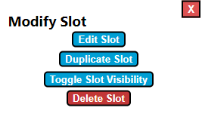

1. Click “Edit Slot”

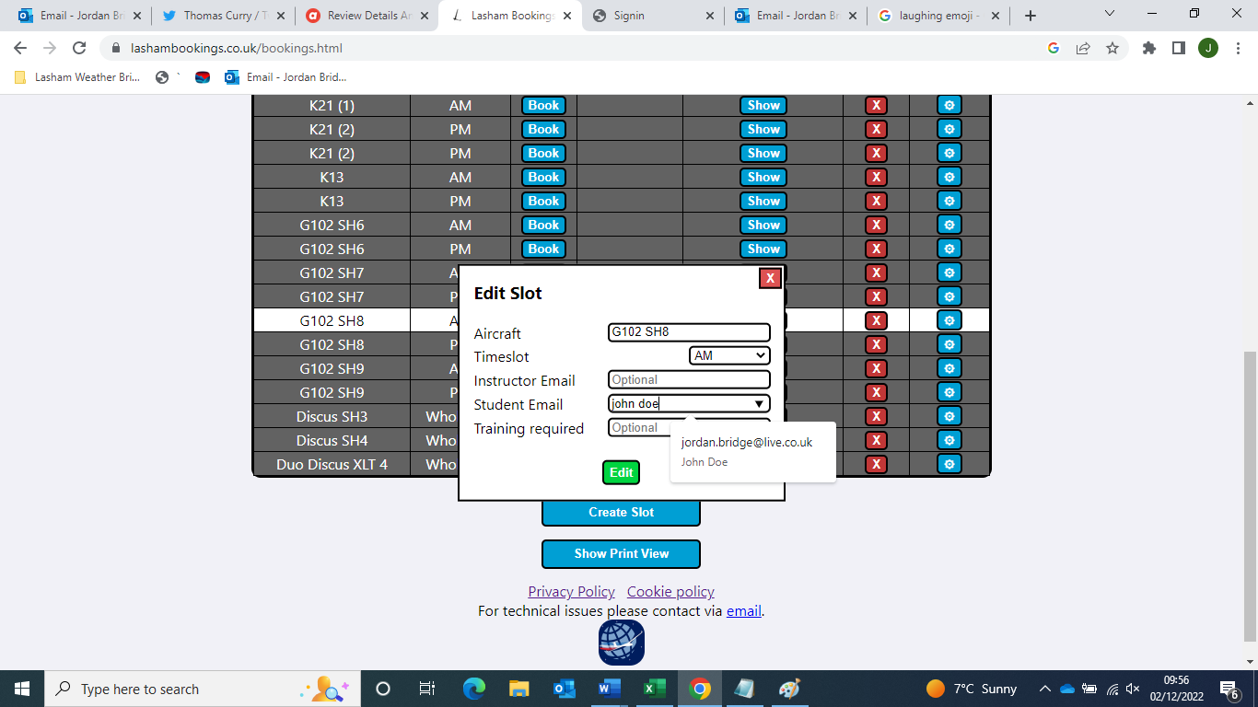

1. Type the pilots name into Student Email

(Note Student Email is the same as Paying Pilot in booking system logic)

1. Click Edit and the booking will be confirmed.

**If the pilot wants to cancel their slot by calling the office (This will allow someone else to book the glider)**

1. Click the Red X



1. The booking will be cancelled

**If a glider goes unserviceable and has to be removed from service.**

1. Click the Cog
2. 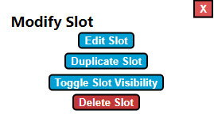Click “Delete Slot”

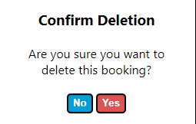

1. Confirm deletion.



1. That glider slot will be deleted.

**Note: You will need to do this for as many days that is required. If a long-term unserviceability (more than 2 weeks) is anticipated contact DCFI or Developer.**

**To create an instructor slot (This will always have to be done by LGS Office, Instructors do not create their own.)**



1. Click Create Slot
2. Fill in details (Mandatory in Red)
   1. 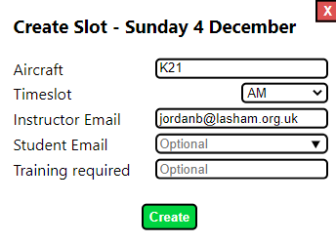Glider Type (K21 or K13 generally, check fleet availability.)
   2. Time AM/PM/All Day
   3. Instructor Name or Email
   4. Student Name or Email if Instructor already knows who they are flying with
   5. If available, training required.
3. Click Create
4. Slot will generate in the system.
5. Repeat as necessary or use (available by clicking the to save time.)

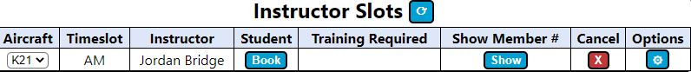

**Changing instructor**

In the event of an instructor change being required. Follow the process described earlier for editing the slot and type the new instructor email in and click edit when complete.

If there is no instructor yet available but it is being searched for, there is an account named INSTRUCTOR TBC which allows us to hold the booking in place.

If an instructor appears unlikely, consider contacting the student and cancelling the slot.

**Student requests different glider for instructor slot to one already booked.**

By default we generally allocate ASK21s to booking slots and use ASK13s when we run out of ASK21s for instructors to use. However occasionally there may betimes where a student requests a K13 with an instructor or vice versa etc due to maintenance plans. If this is the case then we can easily change.

1. Go to the booking in question.
2. Check we have enough of the requested aircraft type.

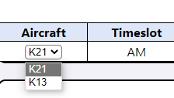

1. Select dropdown to change glider.
2. One selected glider will change for that particular booking.
3. Check that we can’t re-allocate one of the other gliders to solo flying if there is a bigger demand for K13s vs K21s etc.

**Reciprocal Members or Brand New 1 Month Temp Members needing a training booking when they are not registered on the system.**

1. Confirm date and time they wish to book. Remember they will not be able to see the availability.
2. Book the slot as ‘Lasham Office’ and add their names in the remarks column.
3. Temporary members should be given access for the period of their membership but do not give reciprocal members access without permission of CFI/DCFI.

**Forgotten Password**Members are to use the forgotten password feature on the front page. LGS has no control over this process as it is centralised at Amazon Web Services. If they have permanently locked themselves out then you should follow the process to remove them so they can sign up again.



**Removing Member Access from the System** (This process works for members that are not to be approved and members that have locked themselves out of their account.)

Members are to be removed from the system when their membership no longer is valid. A review of this should happen monthly. Sign-Ups to the system who do not appear on Aerolog as valid should also be removed using the below process.

1. Go to Admin Page
2. Enter email address of member to be removed from the system.
3. On clicking Remove a dialogue box will appear confirming their removal. Refreshing the page will show that they have disappeared.

If the scenario involves a member that has locked themselves out of their account permanently by their own doing, then follow the above process and advise them to sign up from the beginning again.

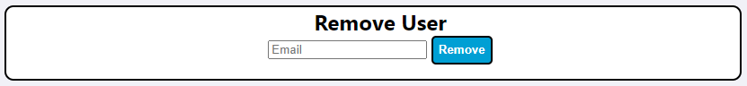

**Manual Sign Up**

This should be a last resort as it is labour intensive. 99% of people are able to do their own sign up.

1. Go to the Admin Portal

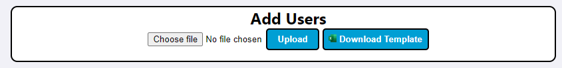

1. Click download template, a CSV file will appear and you will need to open Excel to enter details.
2. Enter the following details
   1. Pilot Email (Be sure that no spaces appear in the email field to avoid system error)
   2. Pilot Name
   3. Membership Number
   4. 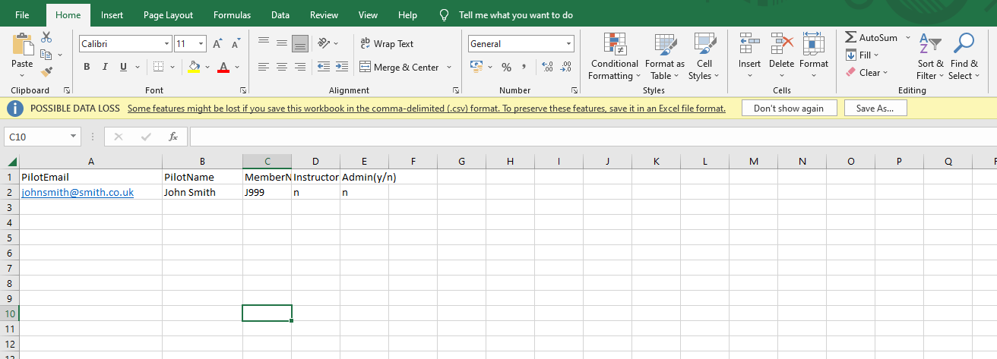Are they an instructor (must be lower case y/n) *Do not grant admin rights to non-staff members under any circumstances to comply with GDPR, double check before saving.*
3. Save the file somewhere you can find it
4. Click ‘Choose File’ and then Upload File
5. Dialogue box will confirm their addition to the system.
6. Send the user an email with this text

*Your access to the Lasham members area and booking system has been set up.*

*Your email address that is registered is the one that this email has been sent to.*

*Your temporary password is: L@shamBookingsTemp1*

*Note, this password is case sensitive and has a special character. It must be entered exactly as above to gain access via the following link-* [*Lasham Bookings*](https://lashambookings.co.uk/)

*Please do not attempt to use the password ASK13 or any other common Lasham password or attempt to use the sign up feature again.*

*You will be prompted to change your password on sign in using the above details. You will then have access to the system using your own password.*

1. The user should now have access.

Technical Help

For Technical Help- Contact Jordan Bridge or Tom Curry by email.

**End of Document**